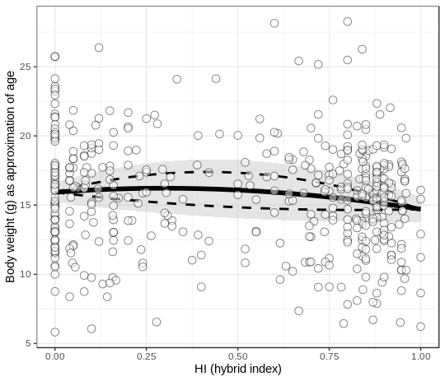

Supplementary Figure S7. No decrease or increase in mortality in more admixed mice. Body weight used as a proxy for age (white dots = individual mice) is constant along the hybrid index. The optimized fit is represented by a solid line, the 95%CI of the fit as all parameters are allowed to vary in their 95%CI, is plotted as a grey ribbon. The 95%CI of the hybridization parameter alpha, as all parameters are fixed to their fitted value while alpha is allowed to vary in its 95%CI, is plotted as dashed lines.

